|  |  |
| --- | --- |
|  | **Carlingford High School**  **Mathematics Extension 1**  **Higher School Certificate**  **Trial Examination 2018** |

**Student Number: ____________________________**

|  |  |
| --- | --- |
| * **General Instructions** * Reading time – 5 minutes * Working time – 2 hours * Write using black pen or blue pen. Black pen is preferred * Board-approved calculators may be used * A reference and MC sheet is provided at the back of this paper * In Questions 11 – 14, show relevant mathematical reasoning and/or calculations | **Total Marks – 70**  **Section I**    **10 marks**   * Attempt Questions 1 – 10 * Allow about 15 minutes for this section   **Section II**    **60 marks**   * Attempt Questions 11 – 14 * Allow about 1 hour and 45 minutes for this section |

|  |  |  |  |  |  |  |
| --- | --- | --- | --- | --- | --- | --- |
|  | **MC** | **Q11** | **Q12** | **Q13** | **Q14** | **Total** |
| **Trigonometry** | /1 | /3 | /3 |  |  | /7 |
| **Perms and combs** | /1 |  |  | /2 |  | /3 |
| **Parametrics** | /1 |  | /6 |  |  | /7 |
| **SHM** | /1 |  |  | /4 |  | /5 |
| **Inequalities** | /1 | /2 |  |  |  | /3 |
| **Rates of change** | /1 |  |  |  | /4 | /5 |
| **Applications of Calculus** | /1 |  |  |  |  | /1 |
| **Circle geo** | /1 |  |  | /2 |  | /3 |
| **Polynomials** | /1 | /2 |  |  | /3 | /6 |
| **Inv trig** | /1 | /2 | 2 |  |  | /5 |
| **Angle betw. 2 lines** |  | /2 |  |  |  | /2 |
| **Divide line in ratio** |  | /2 |  |  |  | /2 |
| **Int by substitution** |  | /2 |  |  |  | /2 |
| **Mathematical Induction** |  |  | /3 |  |  | /3 |
| **3D Trig** |  |  |  | /3 |  | /3 |
| **Growth and decay** |  |  |  | /4 |  | /4 |
| **Inverse functions** |  |  |  |  | /2 | /2 |
| **Integration** |  |  | /1 |  | /2 | /3 |
| **Projectile Motion** |  |  |  |  | /4 | /4 |
| **Total** | /10 | /15 | /15 | /15 | /15 | /70 |

|  |  |
| --- | --- |
| **Section I**  **10 marks**  **Attempt Questions 1 – 10.**  **Allow about 15 minutes for this section.** | |
| Use the multiple-choice answer sheet for Questions 1 – 10. | |
|  | Simplify  (A)  (B)  (C)  (D) |
|  | How many distinct arrangements of the letters of the word ARRANGEMENT are possible?  (A) 2 494 800  (B) 4 989 600  (C) 9 979 200  (D) 39 916 800 |
|  | A parabola has parametric equations  .  What is the Cartesian equation of the parabola?  (A)  (B)  (C)  (D) |
|  | A particle is moving in simple harmonic motion in a straight line. At *t* seconds, it has a displacement of *x* metres from a fixed point *O* on the line, where *x* is given by  . What is the centre of motion?  (A) *x* = –1  (B) *x* = 0  (C) *x* = 1  (D) *x* = 2 |
|  | Solve  (A) *x* > -3  (B) *x* < 0  (C) *x* > 0  (D) *x* < 3 |
|  | Given and , which of the following is the expression for ?  (A)  (B)  (C)  (D) |
|  | How many stationary points does  have?  (A) 0  (B) 1  (C) 2  (D) 3 |
|  | Two circles have a common point *T.*  *PT* is a common tangent to the circles.  *PA* is the tangent to the smaller circle at *Q*.  *PT* = *t* , *QA* = *a* and *QB* = *b*.  Which is an expression for *t* in terms of *a* and *b*.  (A)  (B)  (C)  (D) |
|  | Which expression is not a polynomial:  (A)  (B)  (C)  (D) |
|  | What is the exact value of  ?  (A)  (B)  (C)  (D) |

|  |
| --- |
| **Section II**  **60 marks**  **Attempt Questions 11 – 14.**  **Allow about 1 hour and 45 minutes for this section.** |
| Answer each question in a SEPARATE writing booklet. Extra writing booklets are available.  In Questions 11 – 14, your responses should include relevant mathematical reasoning and/or calculations. |

|  |  |  |
| --- | --- | --- |
| **Question 11** (15 marks) Use the Question 11 writing booklet. | |  |
| (a) | State the domain and range of:  . | **2** |
| (b) | If  , find the value of: |  |
|  | (i) . | **1** |
|  | (ii) . | **2** |
| (c) | Solve  . | **2** |
| (d) | Find the obtuse angle between .  Give your answer correct to the nearest minute. | **2** |
| (e) | The point *P* (10 , 13) divides the interval joining *A*(*x*, *y*) and *B*(7, 7) externally in the ratio 8:3.  What are the coordinates of *A* ? | **2** |
|  | **Question 11 continues on page 6** |  |

|  |  |  |
| --- | --- | --- |
|  | **Question 11 continued** |  |
| (f) | Find using the substitution | **2** |
| (g) | Show that  is a factor of  and hence fully factorise *P*(*x*) over the field of real numbers. | **2** |
|  | **End of Question 11** |  |

|  |  |  |
| --- | --- | --- |
| **Question 12** (15 marks) Use the Question 12 writing booklet. | |  |
| (a) | Two points *P* (2*ap*, *ap*2) and *Q* (2*aq*, *aq*2) lie on the parabola . |  |
|  | (i) Derive the equation of the tangent to the parabola at *P*.  (ii) Find the coordinates of the point of intersection *T* of the tangents to the parabola at *P* and *Q*.  (iii) Show that if the tangents at *P* and *Q* intersect at 45˚.  (iv) Find the locus of *T* by evaluating the expression at *T* and using the result in part (iii). | **1**  **2**  **1**  **2** |
| (b) | (i) Differentiate | **2** |
|  | (ii) Hence or otherwise find | **1** |
| (c) | Prove by mathematical induction that, for  . | **3** |
| (d) | Solve  using the result | **3** |
|  |  |  |
|  | **End of Question 12** |  |

|  |  |  |
| --- | --- | --- |
| **Question 13** (15 marks) Use the Question 13 writing booklet. | |  |
| (a) | The velocity *v* ms-1 of a particle moving in simple harmonic motion along the *x*-axis is given by  , where *x* is in metres. |  |
|  | (i) Between which two points is the particle oscillating? | **1** |
|  | (ii) Find the maximum speed in exact form of the particle. | **1** |
|  | (iii) Find the acceleration of the particle in terms of *x*. | **2** |
| (b) | Jack is running along a path on a horizontal plane.  At a point *A* along the path he notices a tower in the distance on a bearing 048o with an angle of elevation of 12o.  After running 170m further down the path to point *B*, the tower is now on a bearing of 352o with an angle of elevation of 19o.    Find the height of the tower to the nearest metre. | **3** |
|  | **Question 13 continues on page 9** |  |

|  |  |  |
| --- | --- | --- |
|  | **Question 13 continued** |  |
| (c) | Zoolander High School has a student population of 1200.  The number of students (*P)* who have been infected with a flu virus at any given time over the winter is given by: |  |
|  | (i) When *t* = 0, exactly one student at the school is infected with the flu virus.  How many days will it take to infect half the school? | **2** |
|  | (ii) Show that . | **2** |
| (d) | How many ways can 6 people from a group of 13 people be chosen and then arranged in a circle?  . | **2** |
| (e) | *SR* and *PQ* are diameters of the circle, centre *O*.  *QR, PR* and *SP* are chords of the circle.  *TP* is a tangent to the circle.  *RS* is produced to *T*.      Show that | **2** |
|  | **End of Question 13** |  |

|  |  |  |
| --- | --- | --- |
| **Question 14** (15 marks) Use the Question 14 writing booklet. | |  |
| (a) | Consider the function shown below. |  |
|  | 1. As *f(x)* is monotonic decreasing function, an inverse function, , exists.   Find an equation for  . | **2** |
|  | 1. By considering the graphs of *y* = *f(x)* and *y* =   show that  = 129 | **2** |
| (b) | For the cubic equation  = 0 with roots  find the value of : |  |
|  |  | **1** |
|  |  | **2** |
|  | **Question 14 continues on page 11** |  |

|  |  |  |
| --- | --- | --- |
|  | **Question 14 continued** |  |
| (c) | Coal is poured at a constant rate of 1.5 cubic metres per second from a ship onto a conical pile on a dock.  The angle at the apex of the cone is a constant  radians.  At a time, *t* seconds, the height of the cone is *h* metres and the radius of its base is *r* metres. |  |
|  |  |  |
|  | (i) Show that | **1** |
|  | (ii) Show that *V*, the volume of the pile, is given by | **1** |
|  | (iii) Hence find the exact rate at which the height of the pile is increasing when the height of the pile is 6 metres | **2** |
|  | **Question 14 continues on page 12** |  |

|  |  |  |
| --- | --- | --- |
|  | **Question 14 continued** |  |
| (d) | A is plane travelling horizontally above the ocean at a height of 405 metres, with a velocity of 60 m/s.    A payload is dropped from the plane as it passes over *O* which impacts the ocean at *A*.  Using *g* = 10, the equations of motion of the payload are: |  |
|  | (i) It is given that the equation for the horizontal displacement of the payload is    Using calculus, show that the vertical displacement of the payload at time *t* is given by: | **2** |
|  | (ii) How long will it take for the payload to hit the water? | **1** |
|  | (iii) What is the angle of depression  of *A* from *P* as it passes over *O*? | **1** |
|  | **End of Paper** |  |

SCHOOL NAME

**2018**

TRIAL

HIGHER SCHOOL CERTIFICATE

EXAMINATION

REFERENCE SHEET

- Mathematics –

- Mathematics Extension 1–

- Mathematics Extension 2-

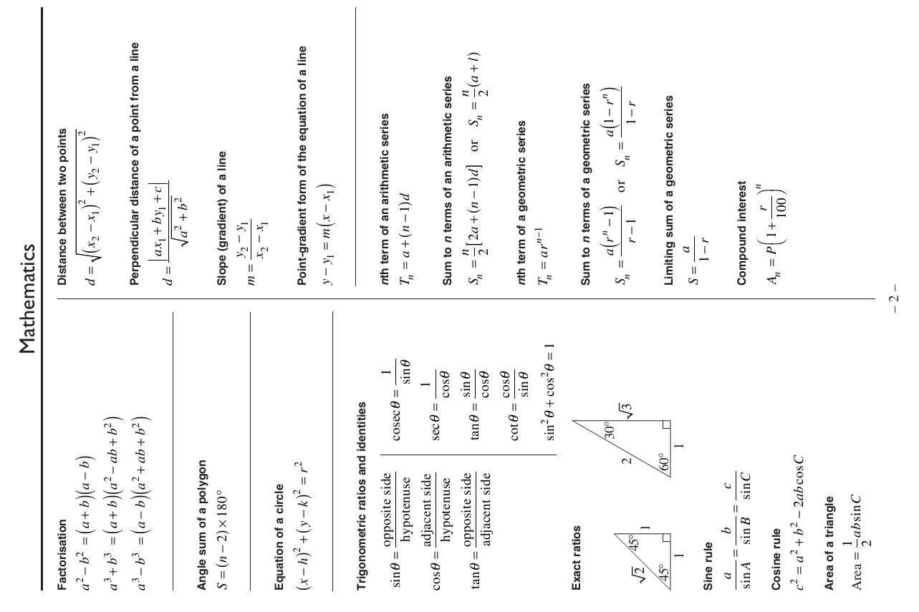

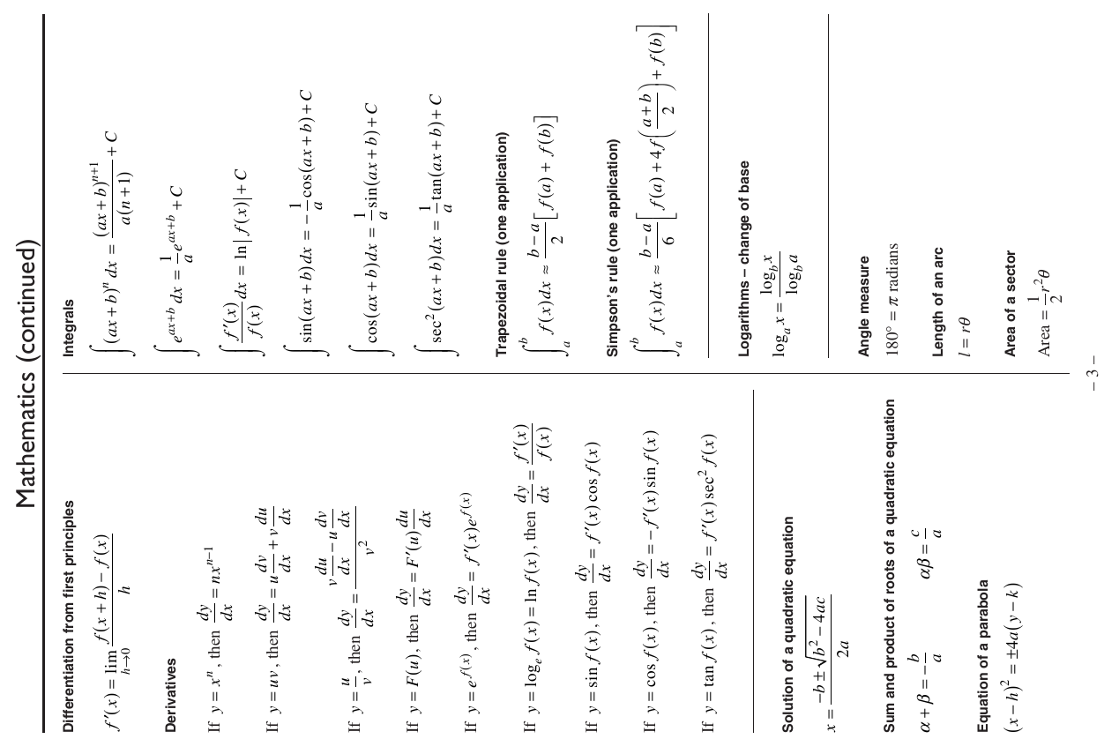

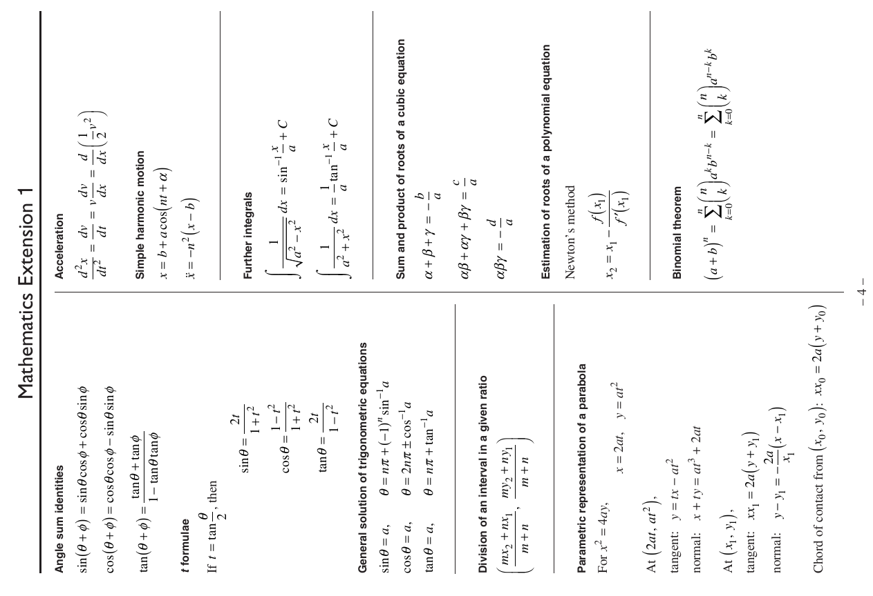

**Trial HSC Examination 2018**

**Mathematics Extension 1 Course**

Name ________________________________ Teacher ________________________

**Section I** – **Multiple Choice Answer Sheet**

**Allow about 15 minutes for this section**

Select the alternative A, B, C or D that best answers the question. Fill in the response oval completely.

|  |  |  |  |  |  |
| --- | --- | --- | --- | --- | --- |
| **Sample:** | 2 + 4 = | (A) 2 | (B) 6 | (C) 8 | (D) 9 |
|  |  |  |  |  |  |
|  |  | A oval2 | B oval-fill | C oval2 | D oval2 |

If you think you have made a mistake, put a cross through the incorrect answer and fill in the new answer.

|  |  |  |  |  |  |
| --- | --- | --- | --- | --- | --- |
|  |  | A oval-fill | B oval-cross | C oval2 | D oval2 |

If you change your mind and have crossed out what you consider to be the correct answer, then indicate the correct answer by writing the word **correct** and drawing an arrow as follows.

|  |  |  |  |  |  |
| --- | --- | --- | --- | --- | --- |
|  |  | A oval-cross | B oval-correct | C oval2 | D oval2 |

1. A B C D

2. A B C D

3. A B C D

4. A B C D

5. A B C D

6. A B C D

7. A B C D

8. A B C D

9. A B C D

10. A B C D